**Practical No: 4** Ninad Karlekar 22306A1012 Date: 14/03/2023

**Aim: Secure management plane.**

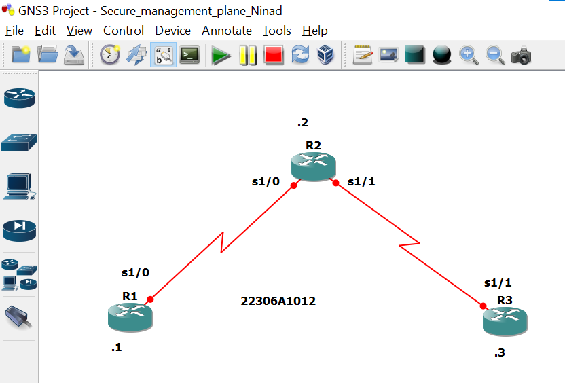

**Take 3 routers -> Configure -> slots -> NM-4T**

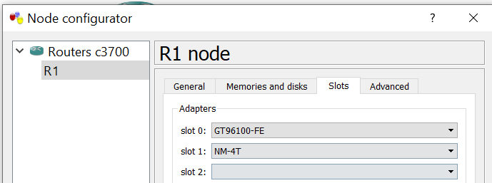

**R1 Console**

R1#

R1#conf t

Enter configuration commands, one per line. End with CNTL/Z.

R1(config)#int s1/0

R1(config-if)#ip add 10.1.1.1 255.255.255.0

R1(config-if)#no sh

R1(config-if)#int lo0

R1(config-if)#ip add 192.168.1.1 255.255.255.0

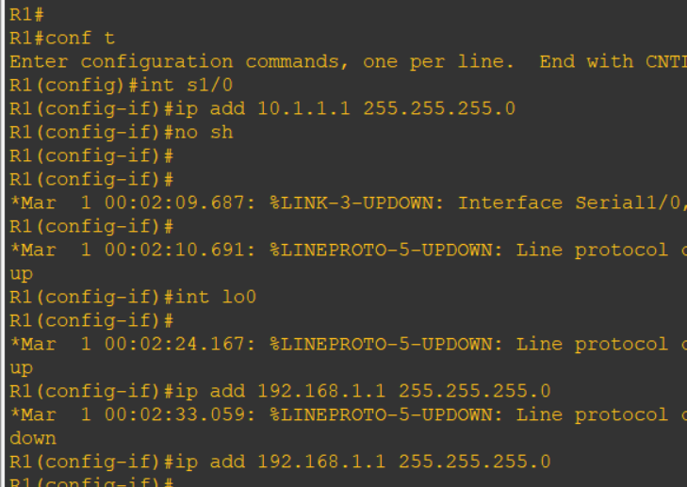

**R2 Console**

R2#conf t

R2(config)#int s1/0

R2(config-if)#ip add 10.1.1.2 255.255.255.0

R2(config-if)#no sh

R2(config-if)#int s1/1

R2(config-if)#ip add 10.2.2.2 255.255.255.0

R2(config-if)#no sh

R2(config-if)#

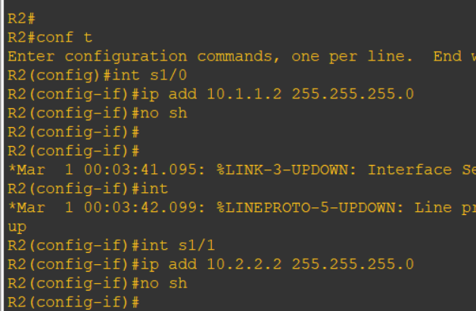

**R3 Console**

R3#conf t

R3(config)#int s1/1

R3(config-if)#ip add 10.2.2.3 255.255.255.0

R3(config-if)#no sh

R3(config-if)#

R3(config-if)#int lo0

R3(config-if)#ip add 192.168.3.3 255.255.255.0

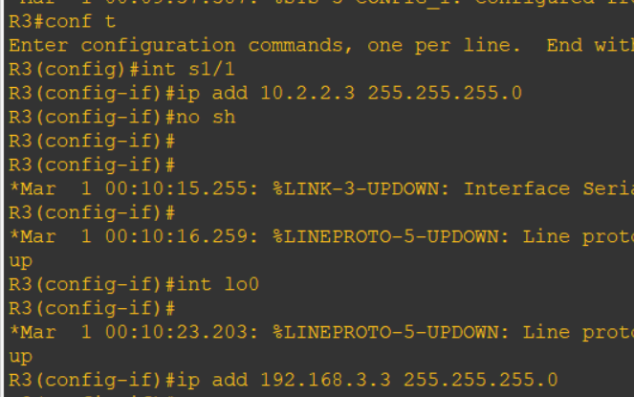

**Part 2 : Routing**

**R1 Console**

R1(config-if)#exit

R1(config)#

R1(config)#ip route 0.0.0.0 0.0.0.0 10.1.1.2

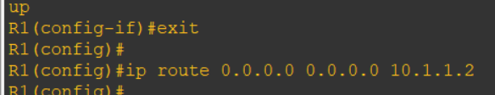

**R2 Console**

R2(config-if)#exit

R2(config)#

R2(config)#ip route 192.168.1.0 255.255.255.0 10.1.1.1

R2(config)#ip route 192.168.3.0 255.255.255.0 10.2.2.3

R2(config)#

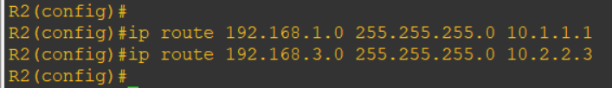

**R3 Console**

R3(config-if)#exit

R3(config)#

R3(config)#ip route 0.0.0.0 0.0.0.0 10.2.2.2

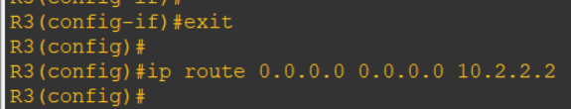

**Ping**

**R1 Console**

R1(config)#do ping 192.168.3.3

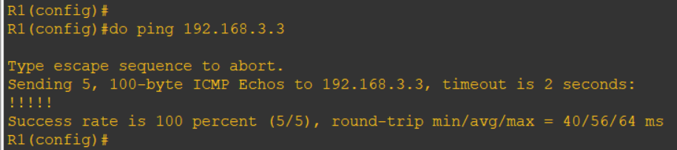

**R3 Console**

R3(config)#do ping 192.168.1.1

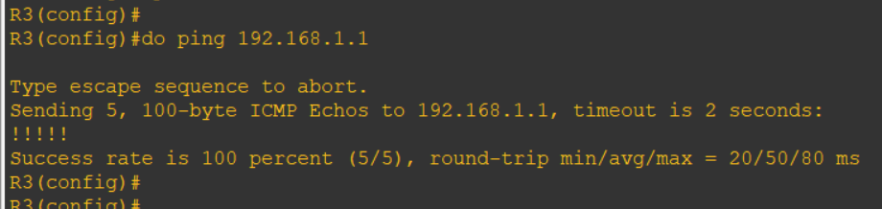

**Part 3: Security Management Access**

**R1 Console**

r1(config)#hostname r1

r1(config)#security password min-length 10

r1(config)#enable secret class12345

r1(config)#

r1(config)#line console 0

r1(config-line)#password ciscoconpass

r1(config-line)#exec-timeout 5 0

r1(config-line)#login

r1(config-line)#logging synchronous

r1(config-line)#exit

r1(config)#

r1(config)#line vty 0 4

r1(config-line)#password ciscovtypass

r1(config-line)#exec-timeout 5 0

r1(config-line)#login

r1(config-line)#exit

r1(config)#

r1(config)#line aux 0

r1(config-line)#no exec

r1(config-line)#end

r1#conf t

Enter configuration commands, one per line. End with CNTL/Z.

r1(config)#service password-encryption

r1(config)#banner motd $Unauthorized access not allowed$

r1(config)#exit

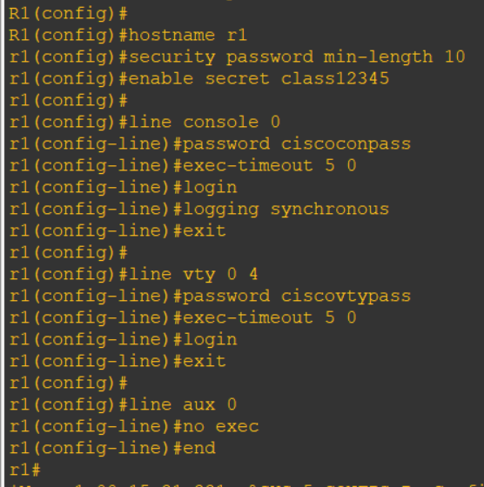

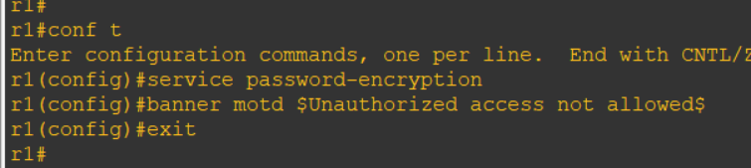

**R3 Console ( Same as R1)**

R3(config)#hostname r3

r3(config)#security password min-length 10

r3(config)#enable secret class12345

r3(config)#line console 0

r3(config-line)#password ciscoconpass

r3(config-line)#exec-timeout 5 0

r3(config-line)#login

r3(config-line)#logging synchronous

r3(config-line)#exit

r3(config)#line vty 0 4

r3(config-line)#password ciscovtypass

r3(config-line)#

r3(config-line)#

r3(config-line)#

r3(config-line)#exec-timeout 5 0

r3(config-line)#login

r3(config-line)#exit

r3(config)#

r3(config)#line aux 0

r3(config-line)#no exec

r3(config-line)#end

r3#

r3#conf t

r3(config)#service password-encryption

r3(config)#banner motd $Unauthorized access not allowed$

r3(config)#exit

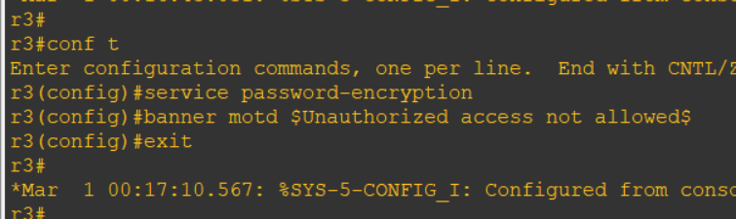

**R3 Console**

r3#telnet 10.1.1.1

(password-> ciscovtypass)

